**PERFORMANCE ANALYZER OF SORTING ALGORITHMS**

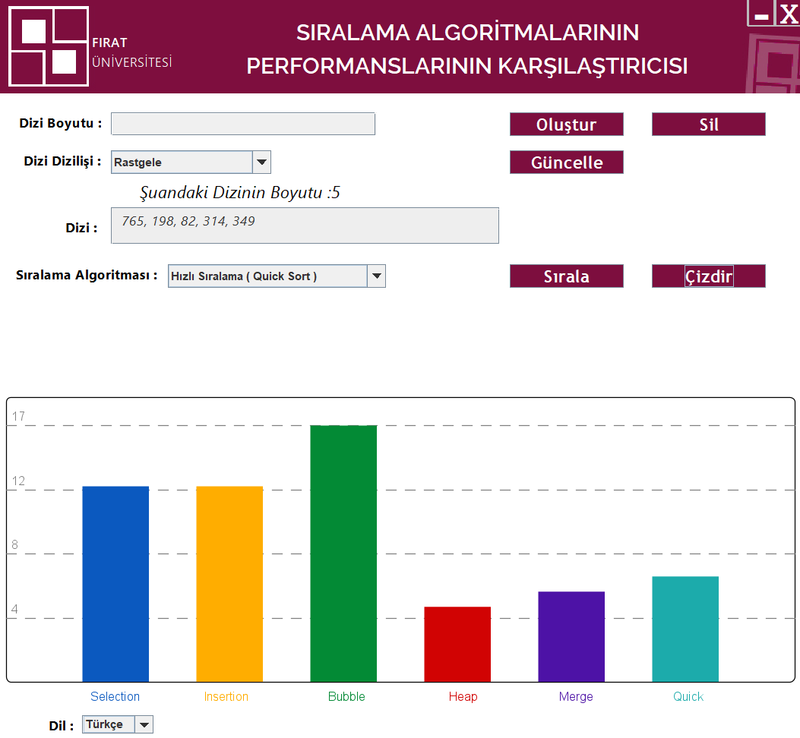**Introduction**

Language : English

Language : Turkish

The Performance Analyzer of Sorting Algorithms is a Java-based tool designed to provide users with comprehensive insights into the efficiency and effectiveness of various sorting algorithms. Sorting algorithms are fundamental to computer science and play a crucial role in many applications, from data processing to algorithmic problem-solving. Understanding their performance characteristics is essential for making informed decisions when selecting sorting algorithms for specific tasks.

This project aims to offer a user-friendly interface for analyzing the performance of seven different sorting algorithms. By leveraging Java's Swing library, the application provides an intuitive graphical user interface (GUI) that allows users to interactively explore the behavior of sorting algorithms and compare their performance under different scenarios.

UI :

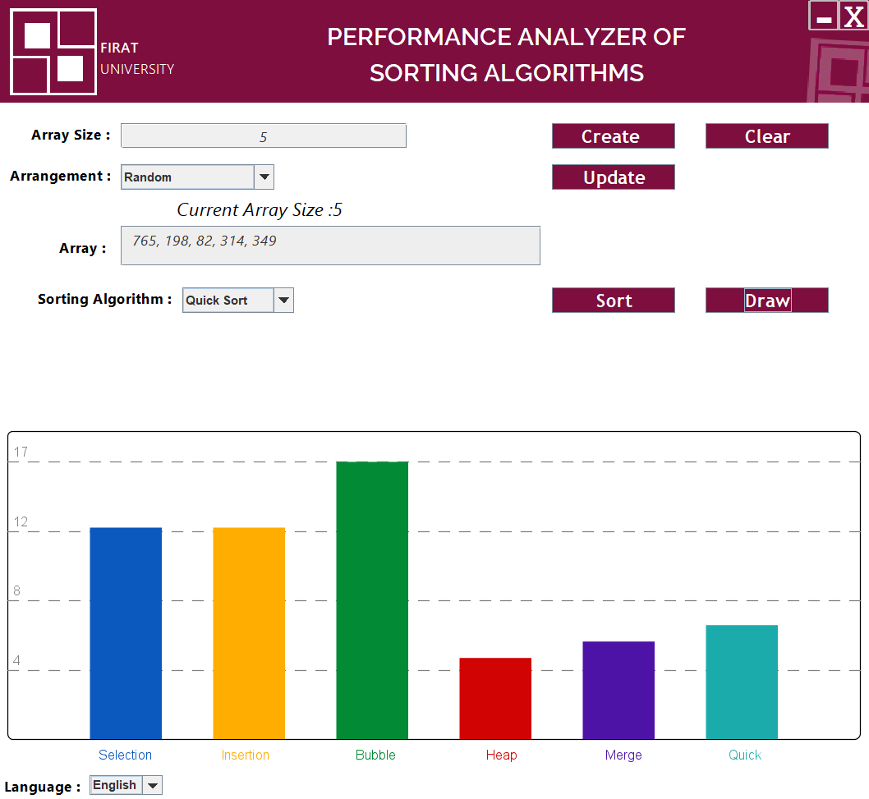

**Features**

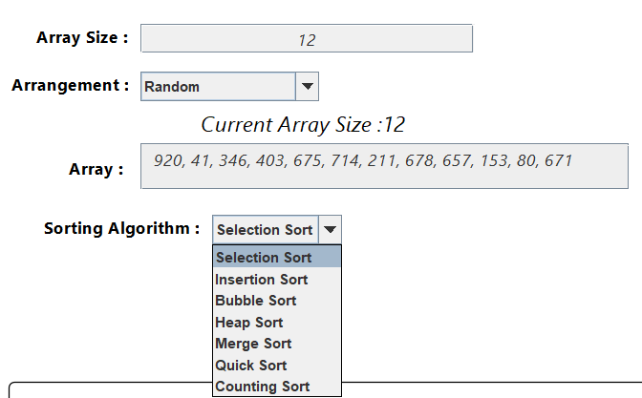

* The tool analyzes the performance of

seven commonly used sorting algorithms,

including Selection Sort, Insertion Sort,

Bubble Sort, Heap Sort, Merge Sort,

Quick Sort, and Counting Sort.

By covering a diverse range of algorithms,

users gain an understanding of their strengths,

weaknesses, and suitability for various use cases.

* 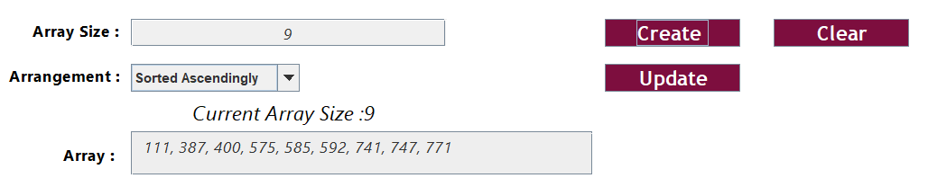Flexible Array Generation Options:

Users have the flexibility to input

array elements manually through

a text field or automatically generate

arrays of desired sizes and arrangements.

The automatic array generation feature

offers options for generating arrays randomly,

in sorted descending order, or in sorted ascending order,

enabling users to tailor the input data to their specific testing requirements.

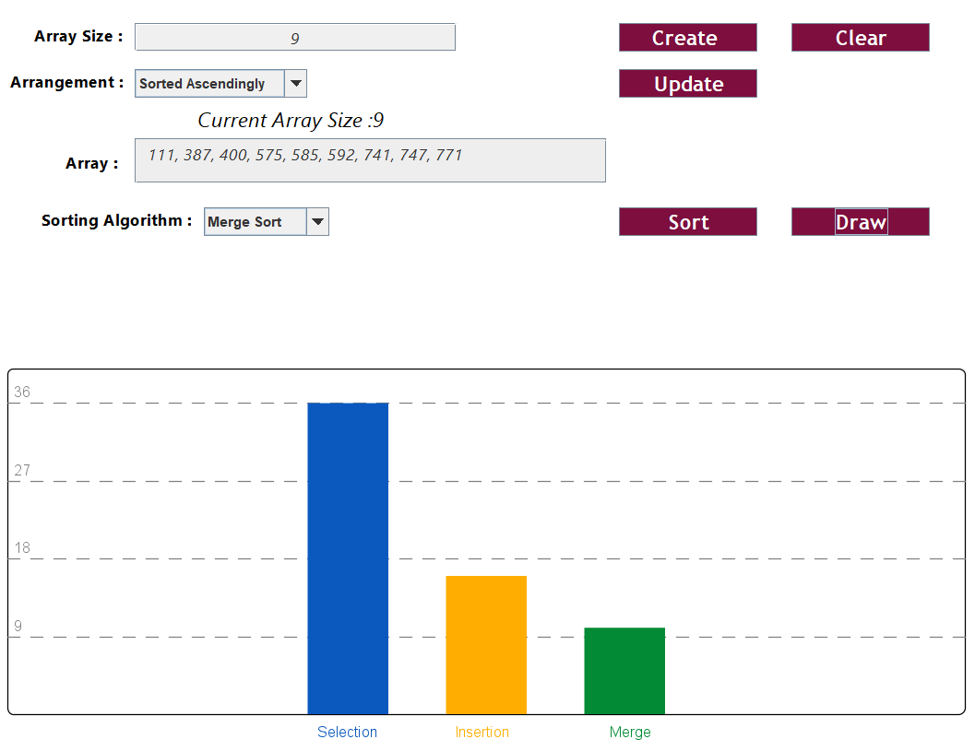

* Interactive Graphical Representation:

The tool visualizes the performance

of sorting algorithms through

interactive bar graphs.

Users can quickly interpret the efficiency of

each algorithm by observing the number of

actions required to sort the array,

facilitating easy comparison and analysis.

* The GUI provides language selection options,

allowing users to interact with the tool

in either English or Turkish.

**Usage Instructions**

1. Clone the repository to your local machine.
2. Compile and run the Java application.
3. Use the GUI interface to input or generate arrays and analyze sorting algorithm performance.

**Credits**

This project is maintained by @malikmaky.

For any inquiries or feedback, please contact malikmhmd@hotmail.com